|  |  |
| --- | --- |
|  | part 1  itani mulaudzi  Web development |

Section A

**Business Name:**

Pro watches

**Logo**



**Business Slogan :**

PRO WATCHES FOR PROFESSIONALS

**Summary of the business:**

Pro Watches is a new watch shop that is located at Kagiso . Pro watches offers watches that are technology advanced and also the most expensive watches in SA .This watches are from different country

**Motivation**

My motivation for creating this website is to help people find themselves or have a good reputation in society because there is a quote that says “if you show me your watch I will tell you the kind of person you are “ and my other motive is that watches are an investment and great watches creates an impression of being successful and fluent

**Objectives**

Pro watches will the next top watch shop in the country because we believe that our watches can motivate people so that they can do better and they can be successful . our watches are the best watches in the country . we work to go beyond expectations so that we can deliver this wonderful watches to our customers

**Website Assets**

**Homepage**

* Business description

PRO WATCHES brings you our exclusive range of affordable and beautiful watches .

Packed with features offering unbeatable value ,our smart watches will keep you fit ,fashionable and fabulous!

We sell stunning stylish replacement straps for Apple watch ,fitbit,Garmin ,  
Samsung devices ,rolex and casio we pride ourselves with on our gorgeours products ,  
exceptional customer service and quick turn around times

**About us**

* Business analysis

Our mission is to merge fashion and fitness through beautifully designed smart watches and stylish accessories .In the next upcoming 10 years we will be manufacturing our own SA watches .We will no longer buy from other country . We will open a store in every country and also open even a store in every province in south Africa .

 PRO  WATCHES  is a wellness company headquartered in SOUTH AFRICA that develops wearable wellness devices for Women and Man.PRO WATCHES is a holistic ,tailor-made approach for both genders It provides easy-to -use and high -tech tools along with personalized programs that combine body and mind self care guides based on the data and scientific approach ,accompanied by an extensive wellness library

**Product and services**

* **Business operation**

Pro watches have a showroom and service room to display and auction some of the watches and order services where customer order their watches .skilled sales and professional watch makers will work together to service and repair watches that are still in the warranty period and those that are being traded in .

* **Business financial plan**

Pro watches will make money by buying new watches from the manufacturer with a lower price and sell them on a higher price and by also buying old watches and service them ,give them a little polish to make them shine again and sell them . we will also offer our customers a service kit .

* S**uppliers**

Most of our watches are from Italy and Spain .That where most watches are made

* **Contact**

Address 13593 Otlega DR

Kagiso ext 8

1754

Contact NO : 0793065516

**Operating Hours**

Monday -Thursday :7AM-5PM

Friday : 8AM-3PM

Weekends : 10AM-3PM

**Email Address**

info@prowatches.co.za

**Photos**

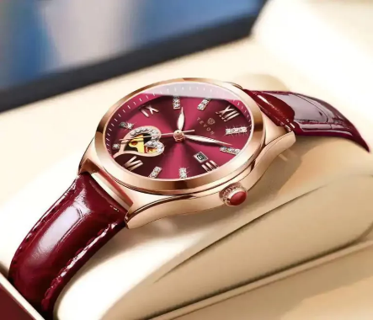

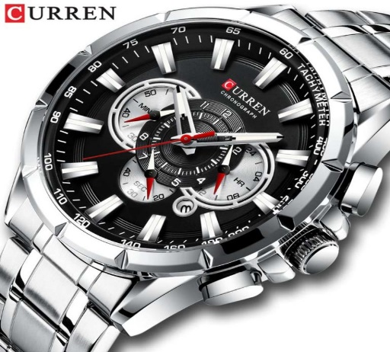

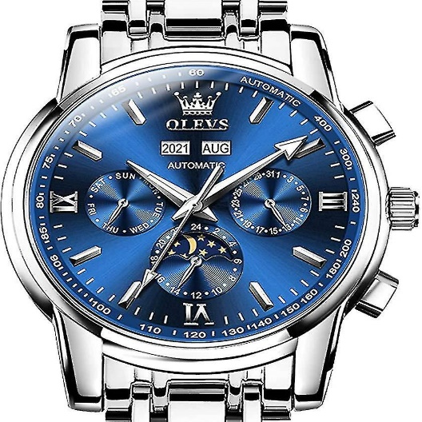

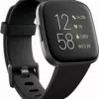

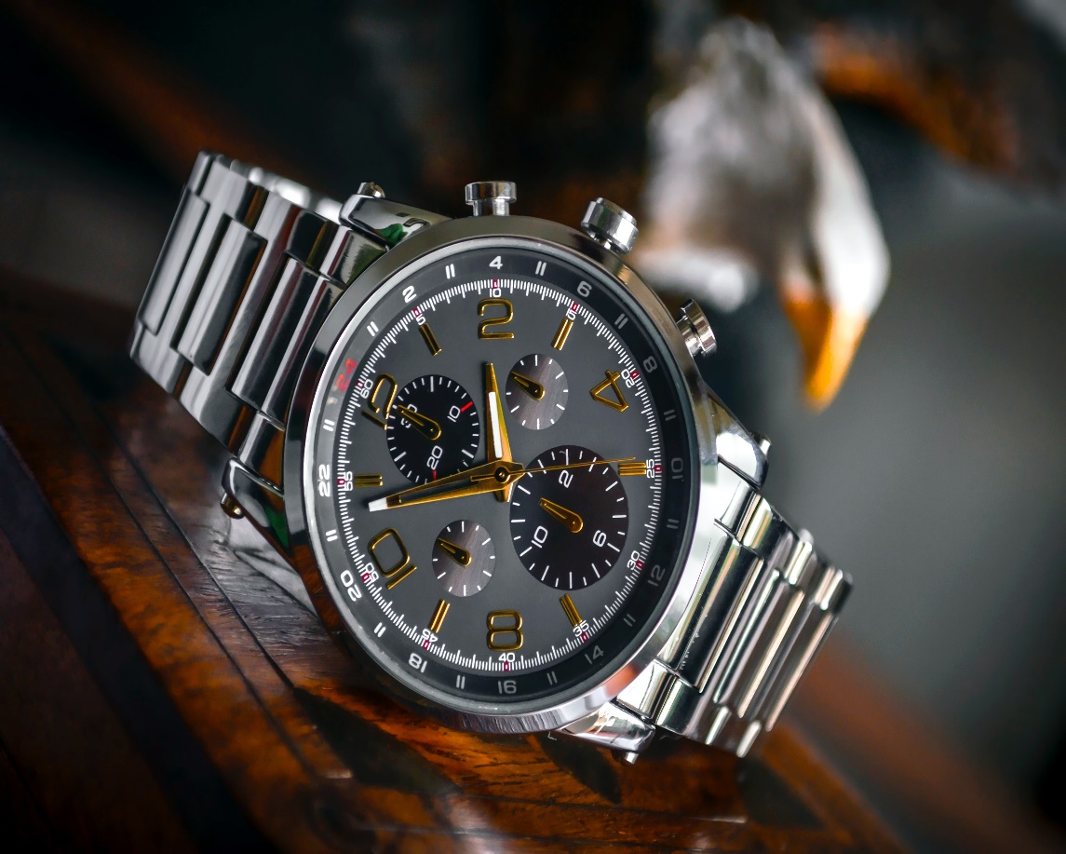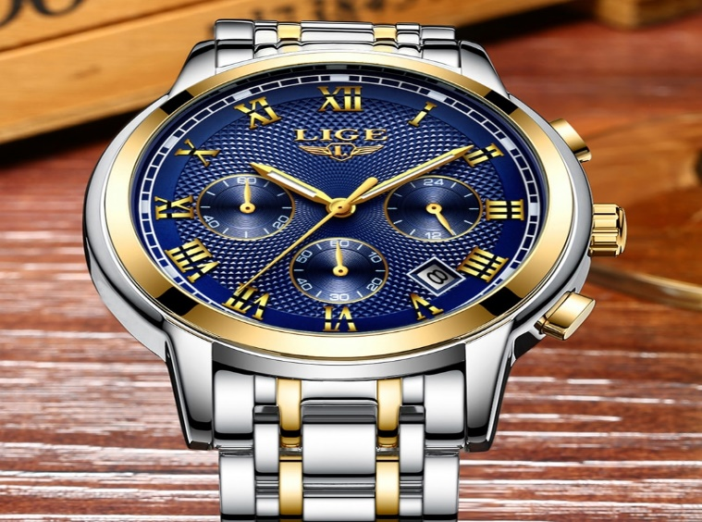

**Section b**

**Webpages**

* **Homepage**
* **About Us**
* **Product and Service**
* **Gallery**
* **Contact**

**Home page**

* Navigation menu
* Business name
* Logo of business
* Summary of business
* Photo
* Business description
* Copyright

**About us**

* Navigation Menu
* Business Logo
* Business analysis
* Business strategy
* Copyright

**Product and service**

* Navigation Menu
* Business Logo
* Business operation
* Business financial plan
* Suppliers
* Copyright

**Gallery**

* Navigation Menu
* Business Logo
* Slide show of showcase cars
* Copyright

**Contact us**

* Navigation Menu
* Business Logo
* Business Address
* Operation Hours
* Contact Details
* Fillable Form (Google Form)
* Location of the business (Google Map)
* Copyright